# MUAAZ SHOAIB

# FA20-BCS-074

# MAD LAB ASSIGNMENT 02

# 16-MAR-2023

## Q1: define a function in JavaScript called clean Names that accepts an array of strings containing additional space characters at the beginning and end. The clean Names () function should use the array map method to return a new array full of trimmed names.

// FA20-BCS-074

// Muaaz Shoaib

function cleanNames(namesArray) {

  const trimmedNames = namesArray.map((name) => name.trim());

  return trimmedNames;

}

const names = ["  Muaaz  ", "   Zaeem   ", "   Almas   "];

const cleanedNames = cleanNames(names);

console.log(cleanedNames);

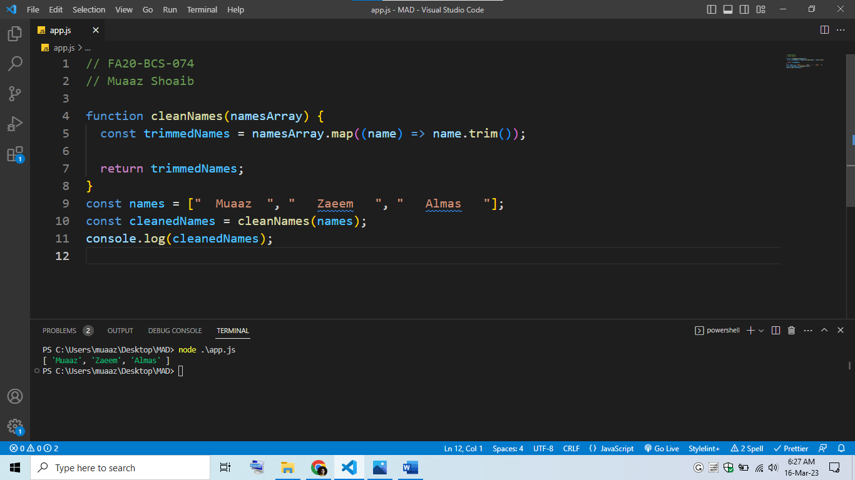

## Q2: Write a JavaScript function that takes an array of 10 elements and returns the sum of all numbers.

// FA20-BCS-074

// Muaaz Shoaib

function sumArrayElements(array) {

  let sum = 0;

  for (let i = 0; i < array.length; i++) {

    sum = sum + array[i];

  }

  return sum;

}

const myArray = [1, 2, 3, 4, 5, 6, 7, 8, 9, 10];

const sum = sumArrayElements(myArray);

console.log(sum);

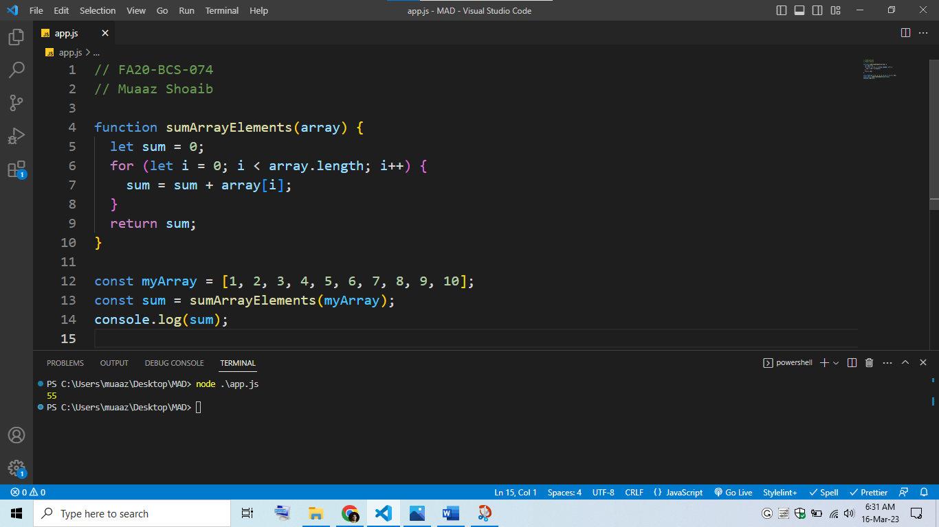

## Q3: Write a JavaScript function that takes an array of 10 elements and returns the sum of even numbers.

// FA20-BCS-074

// Muaaz Shoaib

function sumEvenArrayElements(array) {

  let sum = 0;

  for (let i = 0; i < array.length; i++) {

    if (array[i] % 2 === 0) {

      sum = sum + array[i];

    }

  }

  return sum;

}

const myArray = [1, 2, 3, 4, 5, 6, 7, 8, 9, 10];

const sumEven = sumEvenArrayElements(myArray);

console.log(sumEven);

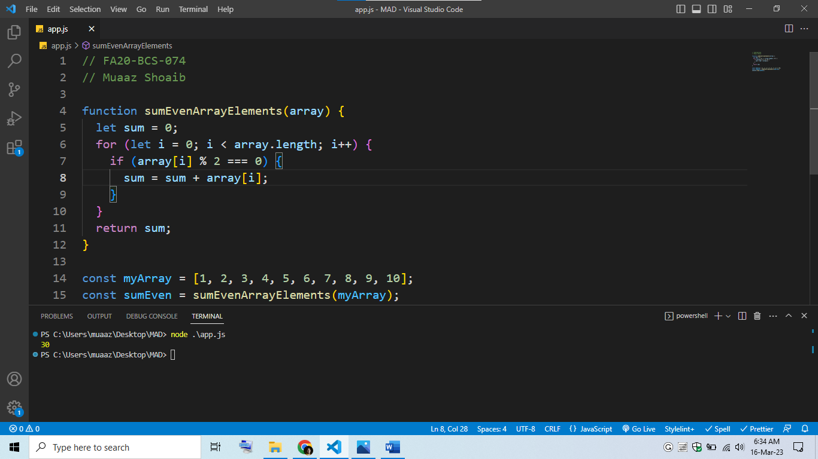

## Q4: Write a JavaScript function that takes an array of 10 elements and returns the sum of odd numbers.

// FA20-BCS-074

// Muaaz Shoaib

function sumOddArrayElements(array) {

  let sum = 0;

  for (let i = 0; i < array.length; i++) {

    if (array[i] % 2 !== 0) {

      sum = sum + array[i];

    }

  }

  return sum;

}

const myArray = [1, 2, 3, 4, 5, 6, 7, 8, 9, 10];

const sumOdd = sumOddArrayElements(myArray);

console.log(sumOdd);

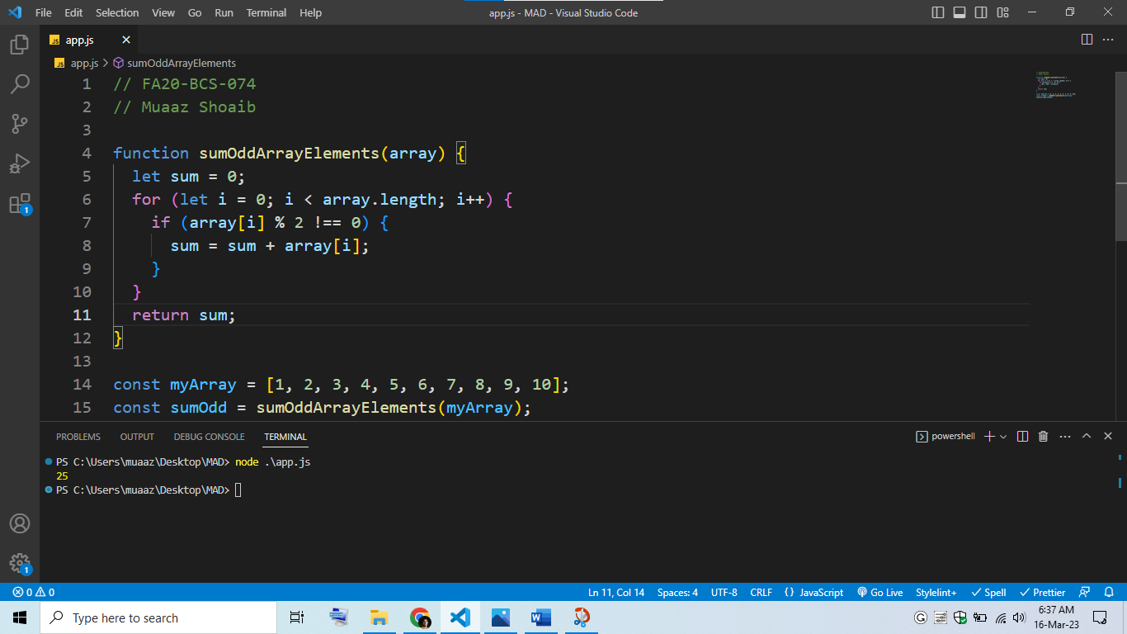

## Q5: Write a JavaScript function that takes an array of 10 elements and returns the multiplication of all numbers.

// FA20-BCS-074

// Muaaz Shoaib

function multiplyArrayElements(array) {

  let result = 1;

  for (let i = 0; i < array.length; i++) {

    result = result * array[i];

  }

  return result;

}

const myArray = [1, 2, 3, 4, 5, 6, 7, 8, 9, 10];

const multiplicationResult = multiplyArrayElements(myArray);

console.log(multiplicationResult);

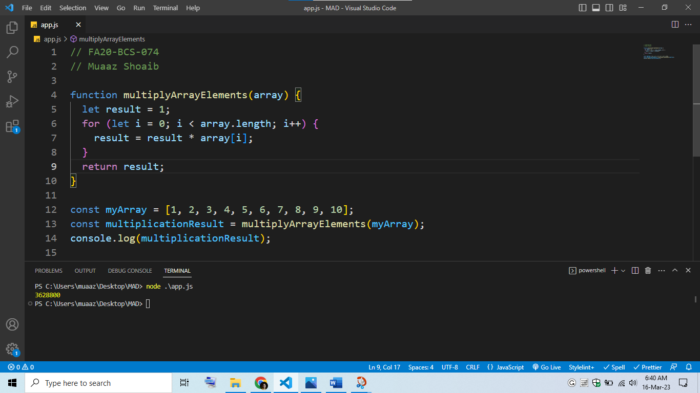

## Q6: Write a JavaScript function that takes an array of 10 elements, finds the cube of all numbers, and stores it in a new array.

// FA20-BCS-074

// Muaaz Shoaib

function cubeArrayElements(array) {

  const result = [];

  for (let i = 0; i < array.length; i++) {

    result.push(Math.pow(array[i], 3));

  }

  return result;

}

const myArray = [1, 2, 3, 4, 5, 6, 7, 8, 9, 10];

const cubeArray = cubeArrayElements(myArray);

console.log(cubeArray);

